# Brainstorm

**TIP**

You can select a sticky note and hit the pencil [switch to sketch] icon to start drawing!

### Before you collaborate

##### A little bit of preparation goes a long way with this session. Here’s what you need to do to get going.

###### 10 minutes

**1**

### Define your problem statement

##### What problem are you trying to solve? Frame your problem as a How Might We statement. This will be the focus of your brainstorm.

###### 5 minutes

**2**

### Brainstorm

##### Write down any ideas that come to mind that address your problem statement.

###### 10 minutes

**3**

### Group ideas

##### Take turns sharing your ideas while clustering similar or related notes as you go. In the last 10 minutes, give each cluster a sentence-like label. If a cluster is bigger than six sticky notes, try and see if you and break it up into smaller sub-groups.

**20 minutes**

ACCURACY

**4**

### Prioritize

##### Your team should all be on the same page about what's important moving forward. Place your ideas on this grid to determine which ideas are important and which are feasible.

###### 20 minutes

### After you collaborate

You can export the mural as an image or pdf to share with members of your company who might find it helpful.

**Quick add-ons**

# & idea prioritization

**A Team gathering**

Define who should participate in the session and send an invite. Share relevant information or pre-work ahead.

**PROBLEM**

**How might we [your problem statement]?**

sujitha

Natural catastrophes are unavoidable, and their

This study used the

random forest

jeeva

Studies analyzing the intensity of natural

Floods impact greatly on human

nivetha

This section defines the overall method for natural disaster intensity

Forest fires drastically affect human lives and

poovarasi

the proposed system’s efficiency and accuracy were tested on several datasets and it outperformed other methods to give the highest results

Convolutional encoder decoder architectures were assembled to maximize the input for information extraction from smoke density images and W-Net was proposed

The CNN model is used to extract flood images from raw images and color filters are used to refine the desired detection

it suggests right decision on saving people from disaster

predicting intensity of the natural disaster with greater accuracy

**TIP**

Add customizable tags to sticky notes to make it easier to find, browse, organize, and categorize important ideas as themes within your mural.

Technology is very essential in dealing with the data

##### It is driven by web

A Share the mural

**Share a view link** to the mural with stakeholders to keep

occurrence has a

significant impact on the

people.

technique for

mapping of wildfire

Populations in underdeveloped countries cannot afford damages disasters cause to infrastructures

disasters have gained lives, economically

analysis and

classification based on

neural network

economic situations,

Use this template in your own

brainstorming sessions so your team can unleash their imagination and start shaping concepts even if you're not sitting in the same room.

**10 minutes** to prepare

**1 hour** to collaborate

**2-8 people** recommended

Set the goal

Think about the problem you'll be focusing on solving in the brainstorming session.

**B**

C Learn how to use the facilitation tools

Use the Facilitation Superpowers to run a happy and productive session.

[Open article](https://support.mural.co/en/articles/2113740-facilitation-superpowers)

### Key rules of brainstorming

To run an smooth and productive session

economy, ecological,

and quality of life for

Floods are the most

properties, human lives and infrastructures

devastating natural disaster, damaging

susceptibility

significant attention in

the current decade

With the help of a

neural network, it is

convolutional neural

possible to predict network and Modified

floods and save the masses from the disaster

and financially

affecting nations.

Particle Swarm Optimization (MPSO), Padmawar

By implementing a

multispectral images

using a multilayered

deep convolutional

proposed approach helps develop a real time fire monitoring system

CNN-based simple feature . It is a hectic job for a

extraction with a AlexNet single deconvolution (SFEwAN-SD)-based

and locating the

victims in a short time

is complex task.

natural disasters

disaster management organization to assess the damage caused by

DATASET

application

algorithms.

## positive experience with user request validation

It offers the ideal solution at the ideal moment and complexity.

results that are reliable for new users

AI is the future assistant for humans

The proposed multilayered convolutional neural network in this research is used to detect and classify the natural disasters

It predicts of how the disasters would impact the area

Technology powers predictions and probability of occurence

them in the loop about the outcomes of the session.

Export the mural

**B**

Export a copy of the mural as a PNG or PDF to attach to emails, include in slides, or save in your drive.

### Keep moving forward

Strategy blueprint

Define the components of a new idea or strategy.

[Open the template](https://app.mural.co/template/e95f612a-f72a-4772-bc48-545aaa04e0c9/984865a6-0a96-4472-a48d-47639307b3ca)

**Customer experience journey map**

Stay in topic. Defer judgment.

Encourage wild ideas. Listen to others.

### Importance

using recent and live data sets to help the prediction

A dataset to make ML Algorithm to work on all worst cases

If each of these tasks could get

## to preserve the data's historical record

Having a simple website makes data extraction easier.

employing automated tasks to process user

Understand customer needs, motivations, and

obstacles for an experience.

[Open the template](https://app.mural.co/template/b7114010-3a67-4d63-a51d-6f2cedc9633f/c1b465ab-57af-4624-8faf-ebb312edc0eb)

**Strengths, weaknesses, opportunities & threats**

Go for volume. If possible, be visual.

#### WHY AI?

Technology powers prediction and probability of occurence

It performs without human intervention

done without any difficulty or cost, which would have the most positive impact?

#### simple application usage

requests

It uses web application block technology to run.

Identify strengths, weaknesses, opportunities, and threats (SWOT) to develop a plan.

[**Open the template**](https://app.mural.co/template/6a062671-89ee-4b76-9409-2603d8b098be/ca270343-1d54-4952-9d8c-fbc303ffd0f2)

[**Share template feedback**](https://muralco.typeform.com/to/CiqaHVat?typeform-source=app.mural.co)

AI is the future assistant for humans

[**Share template feedback**](https://muralco.typeform.com/to/CiqaHVat?typeform-source=app.mural.co)

### Feasibility

Regardless of their importance, which tasks are more feasible than others? (Cost, time, effort, complexity, etc.)

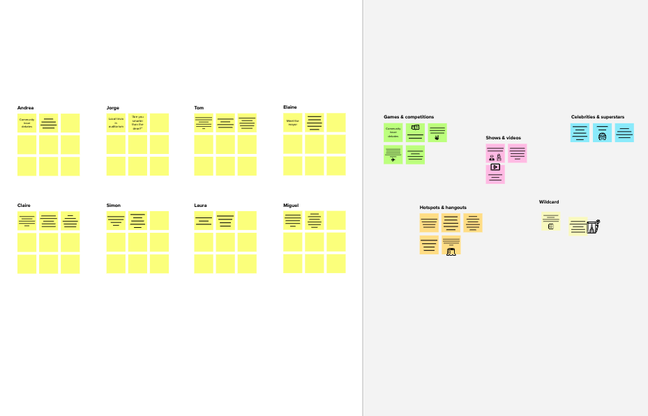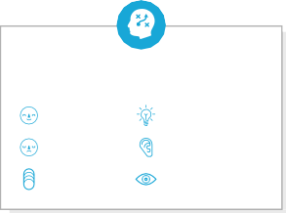

**Template**

**Need some inspiration?**

See a finished version of this template to kickstart your work.

[**Open example**](https://app.mural.co/template/e5a93b7b-49f2-48c9-afd7-a635d860eba6/93f1b98d-b2d2-4695-8e85-7e9c0d2fd9b9)